PRACTICAL – 05

**AIM** : Demo of Analysis of Variance

THEORY:

Analysis of variance (ANOVA) is an analysis tool used in statistics that splits an observed aggregate variability

found inside a data set into two parts: systematic factors and random factors. The systematic factors have a

statistical influence on the given data set, while the random factors do not.

Analysts use the ANOVA test to determine the influence that independent variables have on the dependent

variable in a regression study.

The t- and z-test methods developed in the 20th century were used for statistical analysis until 1918, when

Ronald Fisher created the analysis of variance method. ANOVA is also called the Fisher analysis of variance,

and it is the extension of the t- and z-tests. The term became well-known in 1925, after appearing in Fisher's

book, "Statistical Methods for Research Workers”. It was employed in experimental psychology and later

expanded to subjects that were more complex.

• Analysis of variance, or ANOVA, is a statistical method that separates observed variance data into

different components to use for additional tests.

• A one-way ANOVA is used for three or more groups of data, to gain information about the

relationship between the dependent and independent variables.

• If no true variance exists between the groups, the ANOVA's F-ratio should equal close to 1.

IMPLEMENTATION AND CODE:

1. 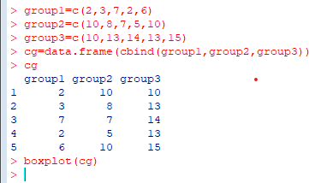CREATE THE DATA IN TO THREE GROUPS
2. **BOXPLOT**

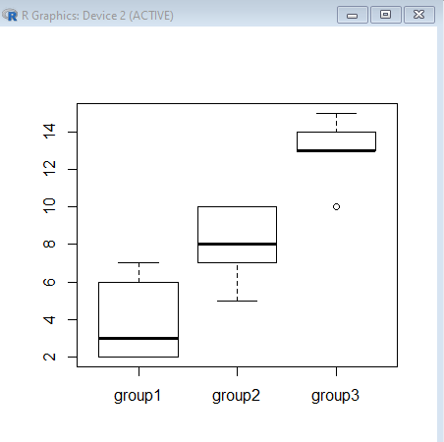

1. TO PRINT THE DATA INTO STACK FORMATE

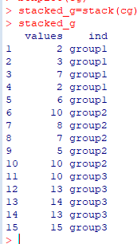

1. CREATE THE DATA IN TO THREE GROUPS

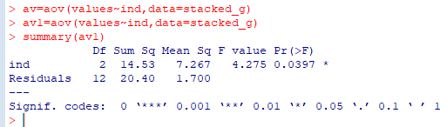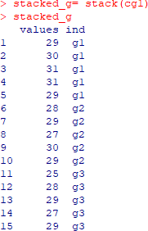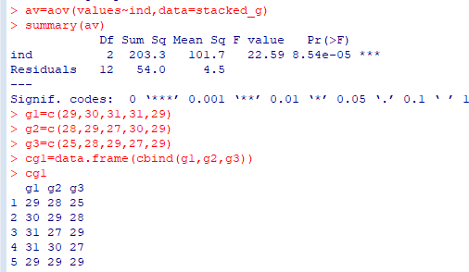

CONCLUSION: Hence we successfully implemented Demo Of Analysis on Variance